ECPS204 Setup-Part B
CHENG-CHIH, LEE, 29329351
JONATHAN KIM, 42411903

Project Description (2 pts)
- The purpose of this part of the project is to prepare the environment for the canny application with the camera and further modify the canny application to process multiple images in a row. Profiling the canny is also included for evaluating the application performance.
- Finally, we want to encode the captured images into a video.

- Experimental Setup (4 pts)
- For this project, we set up a Git repository to exchange files between my RPi and laptop. Following the instructions, we get each step done and recorded.
- We had to use libcamera to do simple camera control since we’re using RPi 5 with newer SW.

- Results (6 pts)
- Step 1 & 2: Install OpenCV and understand the sample code
-OpenCV4 is successfully installed.
-Canny application is implemented and we captured one image of my keyboard as shown below.
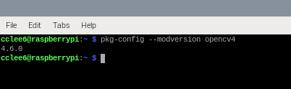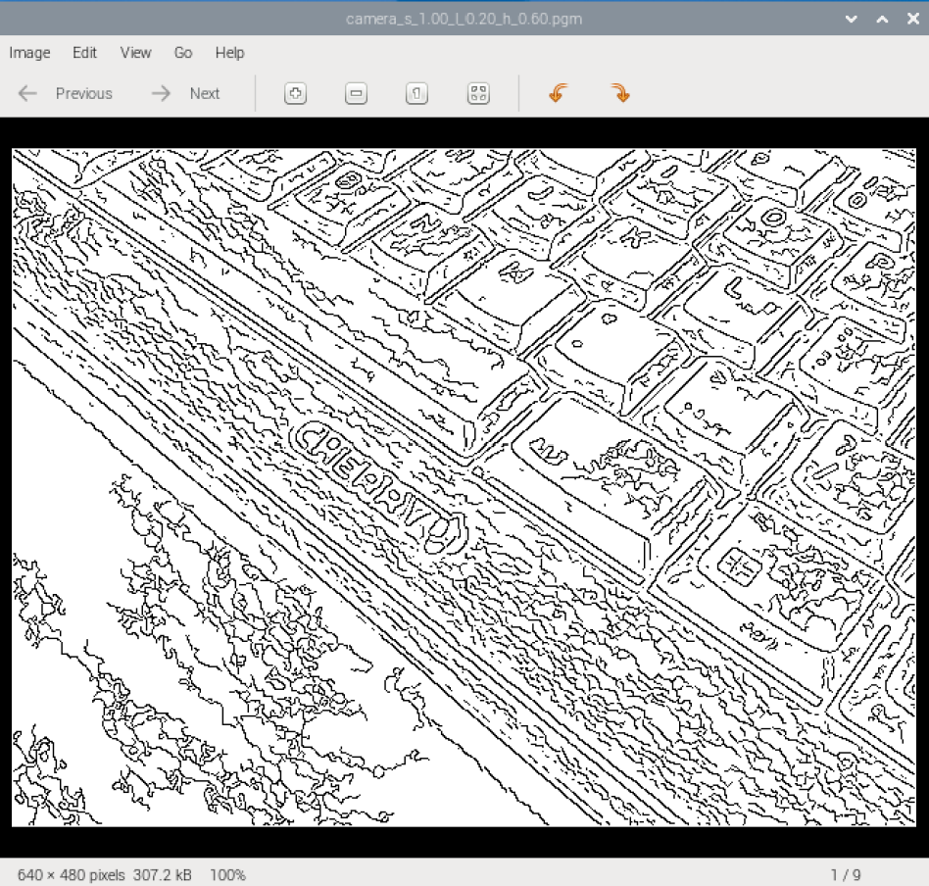
- There are three files included in this project, they are canny_util.c, canny util.h, and camera_canny.cpp.
canny_util.c and canny util.h are the algorithm source code and the header file; camera_canny.cpp is for utilizing the camera to capture images and canny algorithm to process them, including exporting the processed files.
-Quick overview of the sample code:
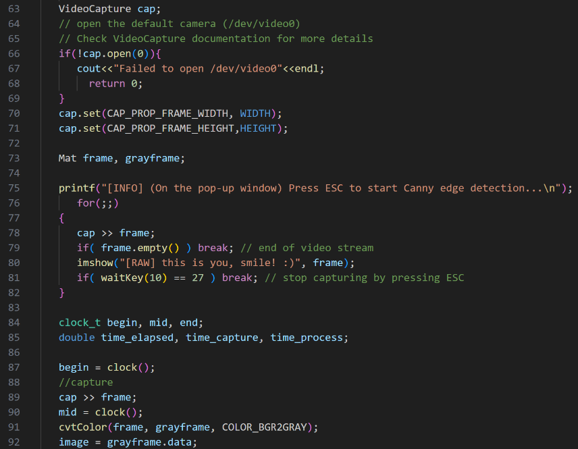
a.Declare VideoCapture cap
b.Open cap and check status
c.Setting width and height of frames
d.Declaring frame and grayframe
e.for loop to show camera images until “Enter” key is pressed
f.Convert captured frame to gray scale and push to canny for processing.

- Step 3: Implement your code for processing multiple images and save in numerical order
We modify the code to capture images in a roll for canny application. You can config to capture by number of frames or time in seconds.
Parameters are now: ./<source file><sigma><tlow><thigh><length/seconds><output folder>
Steps | Results | Comment
Parameter input  ./<source file><sigma><tlow><thigh><length/seconds><output folder> |  | Can set n for frames or s for seconds
Application running | 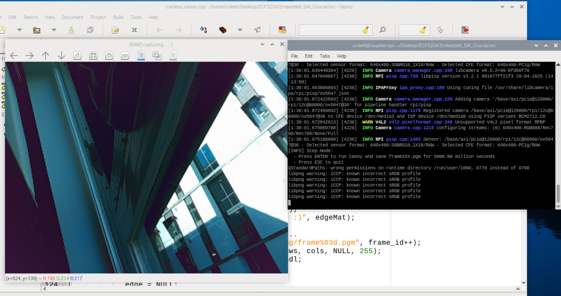 | Application initialized and showing camera views
Files exported to intended directory and files renamed to: frames###.pgm | 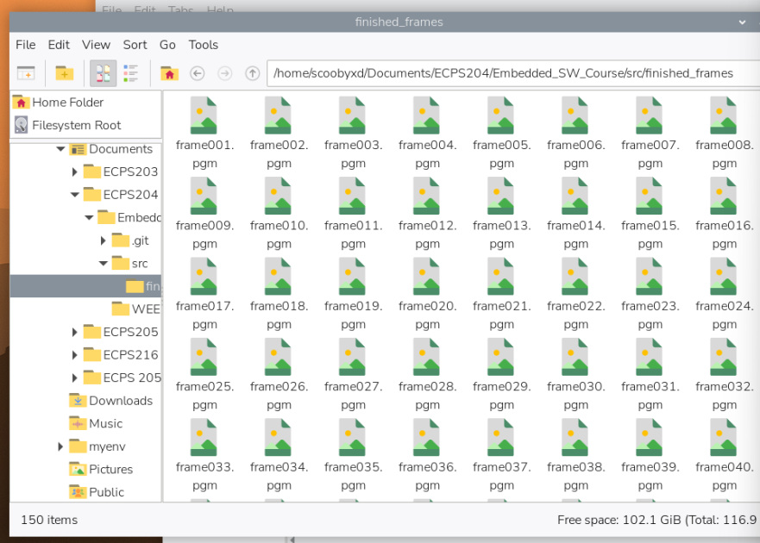 | All the files are now saved in the intended folder and renamed
Turn frames into video in .h264 format | 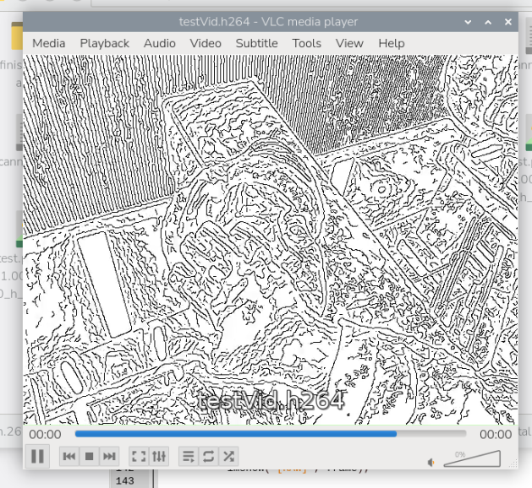 | New video made

- Step 4: Profiling the performance
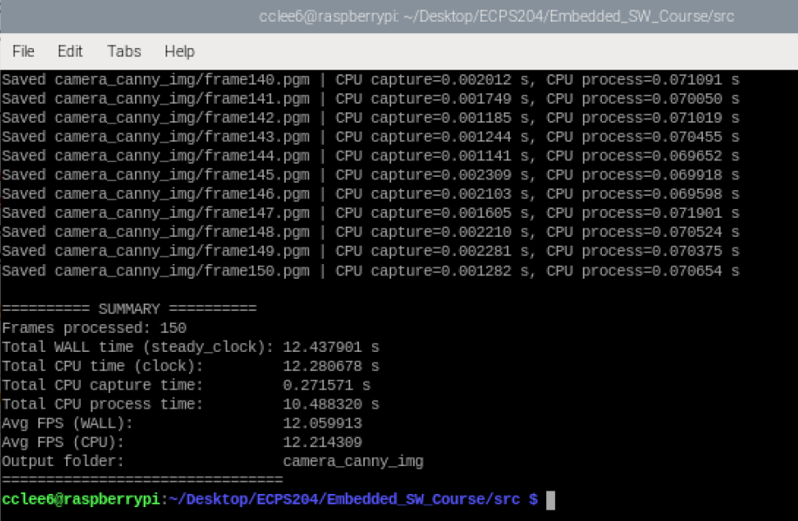
- ========== SUMMARY ==========
- Frames processed: 150
- Total WALL time (steady_clock): 12.437901 s
- Total CPU time (clock): 12.280678 s
- Total CPU capture time: 0.271571 s
- Total CPU process time: 10.488320 s
- Avg FPS (WALL): 12.059913
- Avg FPS (CPU): 12.214309
- Output folder: camera_canny_img
- ================================
4.1/2
We used <chrono> library to measure the Wall time.
The difference between the profiling is that the Wall time (real-world elapsed time) includes the process idle time, time waiting for I/O …etc. The clock() time is for only the process time itself. So, the Wall time is expected to be a bit longer than the process time.

4.3
Difference between WALL time and CPU time: 0.1573 sec
Difference between WALL FPS and CPU FPS: 0.1544 fps

Sometimes, the Wall time gets a bit shorter than the clock() cpu time. Our idea is that the OpenCV does multithreading, leading to the adding-up on the cpu time but the overall (Wall) time is shorter.

4.4
After Adding the “time” command infront of the execution, we have the following markings showing. “time” is a shell tool to do the profiling; real stands for the WALL time, user stand for the CPU time and sys stand for the kernel time.
- real 0m13.038s
- user 0m12.337s
- sys 0m0.594s
They are not matching our measurement, we’ll discuss on it in the discussion part.
- Step 5: Encode your frames into a video
The video is encoded as below.
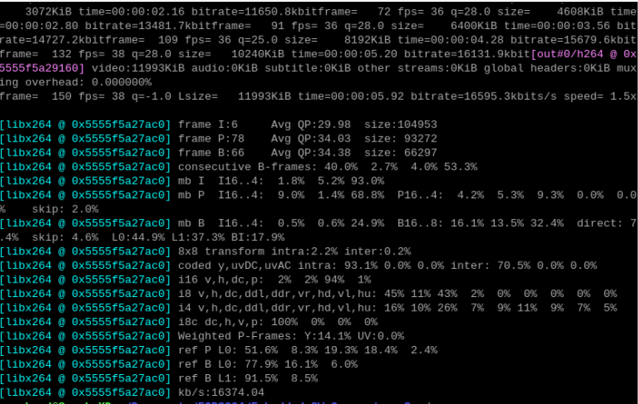

- Problems and Discussion (6 pts)
- Difference between measured ALL time and CPU time. We think it’s because OpenCV is using multithreading, leading to the result.
- The shell time tool result being different from our measured WALL and CPU time. We think it’s because our implementation is ignoring the top and bottom parts of the program, including the initialization and profiling parsing time.
- Conclusion (2 pts)
- In conclusion we set up the Raspberry Pi, OpenCV, made sure it ran canny, and that the camera works as intended with it. We used frames from the camera, split it, measured timing and renamed the frames, and then pieced it back together into a video.

